Swasthya Bhabna Welfare Society
(Registered Under W.B. Societies Registration Act. XXVI of 1961)
Regd. No. : S/95275 of 1999-2000
15/C, Raja K. L. Goswami Street, Serampore, Hooghly-712201, West Bengal, India
Ph: 2652-4899, E-mail : pradipdr@rediffmail.com,Website:-swasthyabhabna.org
…………………………………………………………………………………………………………………
SECRETARY’s REPORT FOR THE YEAR 2018-19
Regarding the main activities performed on behalf of Swasthya Bhabna Welfare Society during the last 1 year, we have undertaken several health awareness programmes such as Mother and Child Health programme, adolescence problems awareness programme in schools and colleges, Cancer detection camps, Dermatological camps, Diabetic detection camps etc. in urban areas. From April 2018 to March 2019, we have organized Health check up camps in schools and voluntary organizations. On 7th April, 2018 at Serampore Mission Girls High School, World Health Day was observed on behalf of Swasthya Bhabna Welfare Society in association with Rajdeep Yoga and Cultural Society where Dr. Pradip Kumar Das, Secretary of the Society spoke on the importance of the Day and by 2030 Health for all and every where and for every body as voiced by a Clarion call by World Health organization by ensuring protective, curative, technological, palliative and improving infrastructural health facilities to all including priority to the underprivileged communities. After Dr Das, Mr. Sudipta Biswas, Secretary of Rajdeep Yoga demonstrated some Yogasana for the fitness and wellness of our body. On 8th April, 2018, on the occasion of World Health Day, a Health Check up camp was organized on behalf of Swasthya Bhabna Welfare Society for the aged persons at the premises of Serampore Pravin Samaj where more than 50 aged persons attended the camp for their Blood Sugar, Blood Pressure, ECG and others check up which was done by our doctor members. On 21st June international Yoga day was observed at Serampore Mission Girls’ High School where speeches were delivered by Dr. Pradip Kumar Das, Secretary of the Society and Mr. Sudipta Biswas, Yoga Teacher of Rajdeep Yoga and culture Society. On 1st July, 2018 at the premises of Serampore IMA Bhavan, a voluntary Blood donation camp was organized by Swasthya Bhabna Welfare Society along with IMA Serampore Branch where 36 donors including 7 female donors donated their blood. On 8th July, Mega Health Check up camp was organized by Swasthya Bhabna Welfare Society in collaboration with IMA, Serampore Branch at the premises of Sugran-Abhijnan of Serampore where more than 200 patients attended the camp for check up for Blood Pressure measurement, ECG, Blood Sugar estimation, BMD camp, Eye check up, Heart check up, Uroflometry test, Thyroid Function and Skin and Hair testing. A dance competition on Spring subject of Rabindra Sangeet was organized by Society in collaboration with IMA, Serampore Branch, Hooghly Zila Nrittya Utsab Samity and Central Dance Academy of Serampore from 18th August to 29th September,2019. Prelimanary selection was done on 18th August, 25th August, 1st September and on 8th September,2019. Final competition was arranged on 29th September, 2019 at Serampore Rabindra Bhavan where Eminent Dance Artist, Mrs. Debjani Chaliah along with Dr. Sumit Basu, Assistant Professor of Sangit Dept. of Viswabharati University were present and they were felicitated on behalf of Society. Successful participants from the age group between 10-15 years and above 15 years to 21 years were given cash prizes, medals, momentums and certificates. A Website in the name of www.swasthyabhabna.org was opened for displaying our activities in the Social Media. A Project on Community Radio Station (CRS) at the premises of Serampore IMA Bhavan was placed to the Broadcasting Dept. of Govt. of India for approval, preliminary enquaries were done and we are waiting for the final approval. Every month, Barannya Bardhyaka Parisebha was given on behalf of Society in collaboration with IMA, Serampore Branch successfully. At present, more than 100 members took the membership in this parisabha. They were brought to Digha and Mayapur within this interval and they enjoyed it very gladly. Arsenic mitigation project through setting up Rainwater harvesting centre at the arsenic affected villages along with arsenic awareness and arsenic detection camps were organized on behalf of Swasthya Bhabna Welfare society in Nonaghata-Uttarpara and Nonaghata-Majherhat villages of Haringhata block under Nadia district from 22th November, 2019 to 10th December,2019 under the leadesrship of Dr. Pradip Kumar Das and others.
Many works were done with the help of our members but there are many things to be undone. But we have a dream to reach to them for the fulfillment of our mission.
With great wishes and thank to all,

Dr. Pradip Kumar Das
Secretary
Swasthya Bhabna Welfare Society

ACTIVITIES OF SWASTHYA BHABNA WELFARE SOCIETY FOR THE YEAR 2018-19
STARTING FROM 1 ST APRIL, 2018 TO 31ST MARCH,2019

1 | Serampore Mission Girls’ High School | 07.04.2018 | Observance of World Health Day by arranging a Socio-Medical Seminar on accessibility of health services to all | 450
2 | IMA Bhavan | 3rd June,2018 | Inaugural ceremony of Old Age Treatment cum Counseling Clinic named as Barannya Bardhyakka Parisebha | 150
3 | Serampore Mission girls’ High School | 21st June,2018 | Observance of International Yoga Day | 350
4 | IMA Bhavan | 24th June,2018 | Health check up camp for the aged persons | 50
5 | IMA Bhavan | 1st July, 2018 | Voluntary Blood Donation Camp and felicitation of Senior Doctor Members of our branch | 36 Donated blood
6 | Surangan-Abhijnan premises | 8th July, 2018 | Mega Health Check up camp along with Blood sugar, ECG, Uric Acid, BMD, Eye check and skin check up etc. | 150
7 | IMA Bhavan | 18th August,18 | Primary selection for Dance Competition for the age group of 10-15 Yrs | 20
8 | IMA Bhavan | 25th August,18 | Primary selection for Dance Competition for the age group of 10-15 Yrs | 15
9 | IMA Bhavan | 1st September,18 | Primary selection for Dance Competition for the age group of 16-21 Yrs | 17
10 | IMA Bhavan | 8th September,18 | Primary selection for Dance Competition for the age group of 10-15 Yrs | 12
11 | Rabindra  Bhavan | 29th September,18 | Final selection for Dance Competition for the age group of 10-15 Yrs & 16-21 Years | 22
12 | Digha Tour | 22nd September,2018 | Excursion for the Aged persons to Digha Tour | 65
13 | IMA Bhavan | 27.10.2018 | Bijoya Sammelan for the Aged persons on Sunday the 27th October, 2018 | 90
14 | Nonaghata Uttarpara & Nonaghata Majherhat Village | From 22nd November to 10 th December 2018 | House to House Arsenic survey works and organization of Arsenic Detection camps and Testing of Arsenic in Drinking water | 400
15 | IMA Bhavan | 15th December,2018 | Mega Health check up camp for the aged persons | 100
16 | IMA Bhavan | 25th December 2018 | Baby Health Check up and Baby Health Show competition | 200
17 | Mayapur Tour | 27th January,2019 | Excursion for the Aged persons to Mayapur Tour | 42
18 | IMA Bhavan | 8th March, 2019 | Observance of International Women’s Day | 100
19 | IMA Bhavan | 15, 16. 17th  March,  2019 | Organization of 3Days Workshop cum Seminar on Health, Hygiene, Nutrition and First Aid in collaboration with NSS Serampore College & Serampore Girls’ College | 100
20 | IMA Bhavan | 23rd March, 2019 | Mega Health Check up camp for the aged persons through Barannya Bardhayaka Parisebha | 65

OBSERVANCE OF INTERNATIONAL WOMEN’S DAY ON BEHALF OF
IMA, SERAMPORE BRANCH
International Women's Day was observed on behalf of Indian Medical Association, Serampore Branch on 8th March, 2019 at Serampore IMA Bhavan where more than 60 eminent personalities attached to different professions were present and felicitated on behalf of IMA Serampore Branch. On behalf of IMA, Serampore Branch , President, Dr. Pradip Kumar Das welcome all the eminent personalities present in the programme and spoke on a lucent voice the importance of observation of this day. On this occasion, a Dance programme on Ritu Ranga was staged by the Students and Teachers of Viswabharati University which was highly appreciated by the audience. The whole programme was conducted by Dr. Pradip Kumar Das.
Dr.P.K.Das
President, IMA, Serampore Branch.

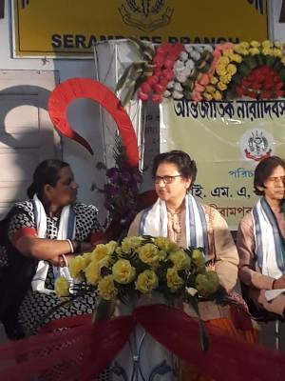
O.C OF SERAMPORE WOMEN POLICE STATION
& DR. SUMIT BASU, PROFESSOR OF VISWABHARATI UNIVERSITY
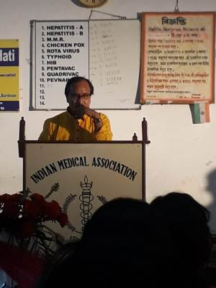
DR. PRADIP KUMAR DAS, PRESIDENT OF IMA SERAMPORE BRANCH
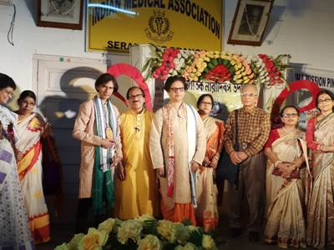
EMINENT PERSONALITIES PRESENT IN THE PROGRAMME
